GRANARD MUNICIPAL DISTRICT

Corporate Affairs,
Aras an Chontae,
LONGFOIRT.

20th September 2016.

To: Each Member of Granard Municipal District.

Dear Member,

You are requested to attend Meeting of Granard Municipal District to be held in
Granard Community Library on Tuesday, 27th September 2016 at 3.30 p.m. to transact business, as set out on the Agenda hereunder.

Yours sincerely,
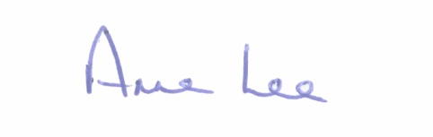

_______________
Anne Lee,
Meetings Administrator.

AGENDA

Prayer before meeting.

1. Confirmation of Minutes of the Municipal District meeting held on the
26th July 2016 - copy enclosed.

2. Matters arising from Minutes.

3. Area Engineer’s Progress Report.

4. Briefing by Gary Brady, Environmental Awareness Officer, regarding the control of Japanese Knotweed.

5. Presentation from Lebeen Park Development.

6. Provision of pedestrian crossing in Ballinalee.

7. That the Municipal District members consider suitable projects which could be developed in advance of funding announcements by Government.

8. 2016/2017 Winter Maintenance Programme.

9. Notices of Motions submitted by Councillors, as listed hereunder -

Councillor Michael Carrigy.

“I call on Longford County Council to carry out road safety works at the crossroads in Ballinalee Village, which leads to both Currycahill Community Centre and the local GAA grounds.”

“I call on Longford County Council to carry out road safety works at Emmett Park, Killoe.”

“I call on Longford County Council to apply for a Low Cost Scheme for additional safety works at Houdens Cross, Ballinascraw, Ballinalee.”

10. A.O.B.

